|  |  |
| --- | --- |
| cetlogo ***CHEMICAL ENGINEERING TRANSACTIONS***  ***VOL. xxx, 2025*** | A publication of  aidiclogo_grande |
| The Italian Association  of Chemical Engineering  Online at www.cetjournal.it |
| Guest Editors: David Bogle, Flavio Manenti, Piero Salatino  Copyright © 2025, AIDIC Servizi S.r.l. **ISBN** 979-12-81206-21-2; **ISSN** 2283-9216 | |

Insert Paper

3D Interfacial Solar Steam Generator Utilizing Reduced Graphene Oxide Decorated with Silver Nanoparticles (Ag@rGO): Synthesis and Application in Seawater Desalination.

Bontle A. Manotoa,\*, Evans MN Chirwaa, Sherperd M. Tichapondwaa, Fisseha A Bezzaa

aWater Utilization and Environmental Engineering Division, Department of Chemical Engineering, University of Pretoria, Pretoria 0002, South Africa

[bontlemanoto@gmail.com](mailto:bontlemanoto@gmail.com)

With increasing global water scarcity, sustainable desalination technologies are essential to ensure water security. Interfacial Solar Steam Generation (ISSG) presents an efficient approach to purifying seawater using solar energy. This study explores the Ag@rGO/PU ISSG device, where silver nanoparticle-functionalized reduced graphene oxide aerogel is integrated with polyurethane sponge for thermal insulation layer. The material was designed to optimize photothermal conversion, water transport, and salt rejection. Pristine graphite was oxidized using Tours method, and the 3D monolith was achieved by thermal reduction. A successful cross-linking of this nanocomposites was confirmed using SEM, TEM, XRD, UV-Vis, Raman, EDX, and BET characterization methods. Experimental results demonstrated enhanced light absorption, high evaporation rates, excellent photoconversion efficiency, and significant antibacterial properties under 1 sun irradiation (1kW.m-2). This device produced clean water at an evaporation rate of 1.42 kg.m-2.h-1 and photothermal efficiency of 98.9% making the Ag@rGO/PU device a promising solution for scalable desalination applications.

**Keywords:** Interfacial Solar Steam Generation, Ag@rGO, Silver Nanoparticles, Desalination, Photothermal Conversion, Water Transport, Heat Localization.

* 1. Introduction

The depletion of freshwater resources and increasing global water demand highlight the need for innovative desalination techniques. Conventional methods such as reverse osmosis and thermal distillation are energy-intensive and suffer from operational challenges, including membrane fouling and brine disposal (Bundschuh et al., 2021). Interfacial Solar Steam Generation (ISSG) leverages photothermal nanomaterials to efficiently convert solar energy into heat, enhancing evaporation while minimizing heat loss to bulk water (Thakur et al., 2024). This study focuses on Ag@rGO/PU, a multifunctional 3D aerogel system integrating reduced graphene oxide (rGO) with silver nanoparticles (Ag-NP) and polyurethane (PU) foam, engineered for high-efficiency desalination. The unique structural and thermal properties of Ag@rGO/PU allow for superior steam generation by optimizing water absorption and heat retention.

Solar-driven desalination is an environmentally sustainable method for freshwater production. ISSG systems utilize photothermal materials to facilitate localized heating at the air-water interface, promoting high-efficiency steam generation (Zhang et al., 2024). The selection of advanced materials plays a crucial role in enhancing evaporation rates and ensuring long-term stability. Recent studies have highlighted the effectiveness of hybrid materials in improving energy conversion efficiency, with Ag@rGO/PU emerging as a leading candidate for sustainable desalination.

Interfacial Solar Steam Generation (ISSG) utilizes advanced materials to enhance solar absorption and water evaporation. Common materials include carbon-based nanostructures like graphene oxide and carbon nanotubes, which provide excellent light absorption and heat localization. Metallic nanoparticles, such as gold or silver, improve solar-to-thermal conversion efficiency (Saeed et al., 2024).

Graphene oxide (GO), synthesized from graphite, is rich in oxygen-containing functional groups such as hydroxyl (-OH), carboxyl (-COOH), and epoxy (-O-), which facilitate dispersion in aqueous solutions. However, the presence of these groups disrupts its electronic structure, limiting its thermal and electrical conductivity (Yang et al., 2019). Through chemical or hydrothermal reduction, GO can be converted into reduced graphene oxide (rGO), restoring its conjugated π-network and enhancing its photothermal efficiency. Reduced graphene oxide (rGO) is a widely studied photothermal material due to its excellent optical absorption, broad spectral range, and thermal conductivity making it an ideal candidate for efficient light-to-heat conversion (Hidayah et al., 2017). Additionally, rGO materials are not only cost effective and sustainable but also features a highly porous structure that ensures lightweight, efficient water distribution required for efficient ISSG (Li et al., 2024).

Functionalization with silver nanoparticles (Ag-NP) as discussed by Sharma and Rabinal (2017) enhances light absorption through localized surface plasmon resonance (LSPR) effect. Ag-NPs exhibit strong optical absorption in the visible and near-infrared regions, amplifying the heat localization at the evaporation interface. Additionally, their antimicrobial properties help prevent biofouling, extending the operational lifespan of ISSG systems. Furthermore, it increases hydrophilicity thereby further optimizing ISSG performance. By integrating Ag-NPs into rGO frameworks, the resulting Ag@rGO hybrid material achieves superior light absorption, efficient energy conversion, and enhanced salt rejection, making it an excellent candidate for next-generation solar desalination technologies.

The porous self-assembled 3D structure of rGO-based aerogels further improves their light absorption, water transport capabilities, and thermal insulation properties, optimizing their performance in solar-driven desalination systems (Zhou et al., 2024). The ISSG design and working mechanism as investigated by Sun et al., (2024) and highlighted factors of importance as heat management and water transport. The integration of polyurethane sponge provides additional insulation, reducing conductive heat loss to bulk water, increasing water transport to the absorber and allowing for more efficient steam production by retaining localized heat within the absorber layer (Farhadipour et al., 2024).

* 1. Methods
     1. Synthesis graphene oxide (GO)

Graphene oxide (GO) was synthesized using an improved Tour’s method (Habte, 2019). Graphite powder (20 µm) was oxidized in a 9:1 mixture of H₂SO₄ and H₃PO₄ using KMnO₄ at 50°C for 24 hours. The reaction was quenched with iced DI water and further treated with H₂O₂ (30 wt.%) to reduce manganese residues. The product was washed with HCl (10 wt.%) and ethanol, then purified by repeating the process 6 times. GO was oven-dried at 60°C, pre-frozen at -72°C, and freeze-dried at -50°C (0.001 kPa) for 24 hours before storage.

* + 1. Synthesis of silver nanoparticles (Ag-NPs)

Silver nanoparticles (Ag-NPs) were synthesized using a **bottom-up chemical reduction method** following the methodology described by Yerragopu et al. (2020) and Mavani & Shah (2013). Using **tri-sodium citrate (TSC) and sodium borohydride (NaBH₄)** as stabilizing and reducing agents. A **1.5 M AgNO₃ solution** was heated to **90°C**, followed by the dropwise addition of **1% TSC** under continuous stirring. To control particle size and morphology, **5 M NaBH₄** was added dropwise to the **AgNO₃/TSC mixture** under ice bath conditions, facilitating Ag ion reduction and preventing agglomeration. The resulting **grey Ag-NPs** were filtered and stored in **amber bottles** to prevent light-induced degradation, ensuring stability for further analysis.

* + 1. Fabrication of Ag@rGO ISSG

A reduced graphene oxide decorated with silver nanoparticles (Ag@rGO) monolith was synthesized via hydrothermal reduction. Silver nanoparticles were incorporating into 50mg/ml of GO dispersion and sonicated for 1.5 hours, followed by vigorous stirring for 2 hours at room temperature. The homogeneous mixture was transferred into a 50 mL Teflon-lined autoclave and heated at 180°C for 16 hours. After cooling, the sample was washed with 10% ethanol, pre-frozen at -62°C for 24 hours, and freeze-dried at -50°C (0.001 kPa) for 72 hours.

* + 1. Experimental setup

Carbon-based aerogels were integrated into a double-layer interfacial solar steam generation (ISSG) system by incorporating them as the top layer over an insulating substrate. The insulating layer for all ISSG configurations consisted of a porous polyurethane (PU) sponge with dimensions of 5 cm × 6 cm × 6 cm. The ISSG assembly was placed in a beaker containing 400 mL of artificial seawater with a salinity of 3.5%. The solar steam generation performance was assessed under 1 sun illumination for 3 hours using an Oriel LCS-100™ solar simulator. Temperature variations and thermal distribution were monitored across the system using an infrared (IR) camera (FLIR TG165)

* 1. RESULTS AND DISCUSSIONS
     1. Characterization by XRD

The XRD pattern confirms the successful synthesis of the Ag@rGO composite shown in table 1. The **(002)** peak indicates the presence of reduced graphene oxide (rGO), with broadening suggesting structural disorder. The sharp peaks at **(111), (200), and (220)** correspond to the face-centred cubic (FCC) structure of silver (Ag) nanoparticles, confirming their incorporation. The dominant **(111)** peak suggests preferential crystallographic growth, while peak broadening indicates nanoscale particle size. The presence of the (200) and (220) peaks further confirms the successful incorporation of silver nanoparticles into the rGO matrix. Overall, the results validate the formation of a hybrid Ag@rGO nanocomposite, suitable for applications in catalysis, sensing, and photothermal processes.

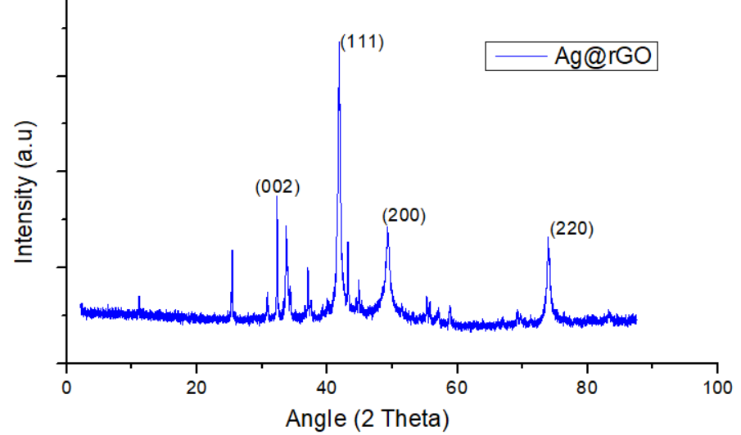

*Figure 1: XRD results for Ag@rGO material*

* + 1. Characterization by Fourier-transform infrared (FTIR)

Fourier-transform infrared (FTIR) spectroscopy confirm the structural evolution from GO to rGO and Ag@rGO as shown in figure 2. GO exhibits strong oxygen-functional group peaks, including O–H stretching vibrations from hydroxyl group (3216 cm⁻¹), C=O (1712 cm⁻¹) confirming the presence of carboxylic and carbonyl functionalities, and C–OH (1428 cm⁻¹), indicating extensive oxidation. The rGO spectrum shows a significant reduction in these peaks, confirming successful deoxygenation. Ag@rGO exhibits further attenuation of oxygen-related bands, suggesting strong interactions between Ag nanoparticles and rGO. The results validate the structural modifications, making Ag@rGO a promising material for photothermal conversion, catalysis, and sensing applications.

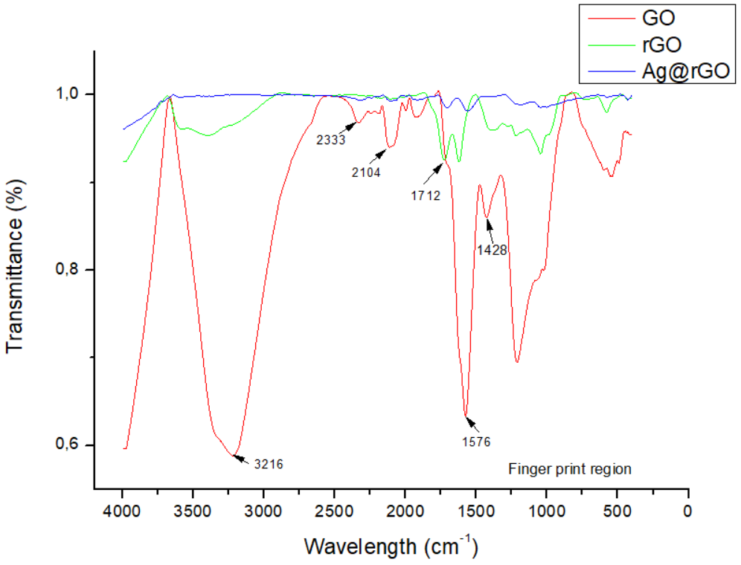

*Figure 2: FTIR results showing oxygen containing functional group of Ag@rGO in comparison with GO and RGO materials*

* + 1. Characterization by Brunauer-Emmett-Teller (BET) and Density Functional Theory (DFT)

The BET and DFT analyses according to the IUPAC classification (Thommes *et al*., 2015) confirms that Ag@rGO exhibits a **mesoporous structure** with a **Type IV(a) isotherm and an H3 hysteresis loop**, indicating slit-shaped pores formed by rGO sheet aggregation due to plate-like reduced graphene oxide sheets. The BET surface area of Ag@rGO increased significantly from 26.07 m²/g of pure rGO to **96.54 m²/g**, attributed to silver nanoparticle decoration, which prevents rGO restacking. The DFT pore size distribution **average pore size (20.21 nm) and pore volume (0.08635 cm³/g)** confirm the material's mesoporous. The presence of "ink bottle" pores slightly broadens the hysteresis loop. These structural enhancements make Ag@rGO suitable for applications in **solar steam generation, catalysis, and adsorption-based processes.**

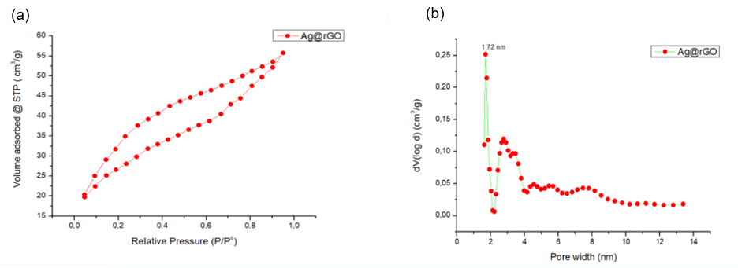

*Figure 3: BET and DFT results for Ag@rGO solar absorber material*

* + 1. Characterization by Scanning Electron Microscopy (SEM) and Transmission electron microscopy (TEM)

The SEM images confirm that Ag@rGO exhibits a **highly porous, crumpled sheet-like morphology**, preventing graphene restacking and enhancing surface area. The presence of **well-distributed silver nanoparticles** suggests successful deposition, improving conductivity and catalytic activity. The interconnected **mesoporous and macro-porous structure** supports efficient adsorption and fluid transport, aligning with BET analysis results. These characteristics make Ag@rGO a promising material for **solar steam generation, catalysis, and adsorption applications.** Image a showed a wrinkled and folded morphology of GO due to the introduction of oxygen containing functional groups during oxidation (Liu et al., 2022).

High magnification TEM image (c) showed a wrinkled and layered morphology with the presence of FCC structured AgNP correlating with the XRD results.

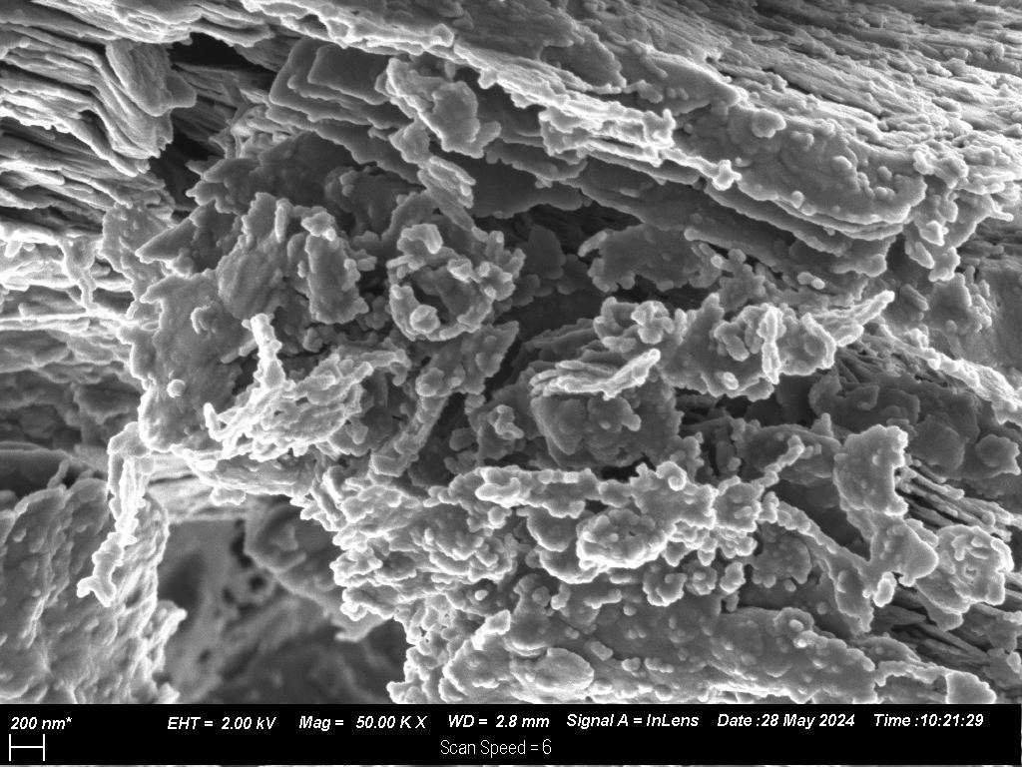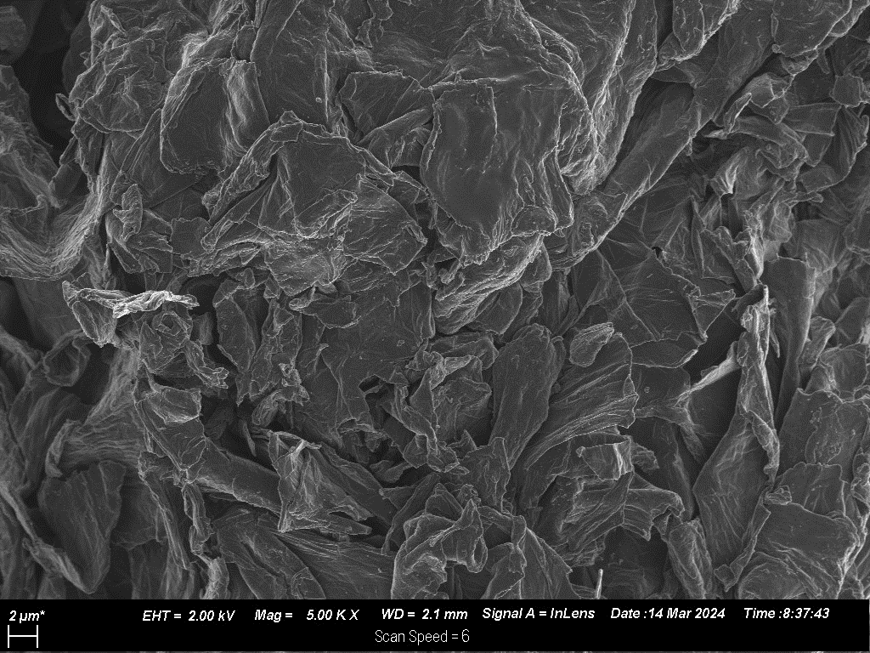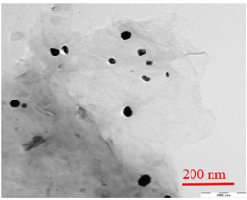

(a)

(b)

(c)

200nm

2µm

Figure 4: SEM image showing exfoliated GO image at 2µm (a), Ag@rGO at 200 nm resolution (b) and TEM image of Ag@rGO at 200 nm resolution.

* + 1. Characterization by Ultraviolet-visible Spectroscopy (UV-Vis)

The UV-Vis absorption spectrum of Ag@rGO reveals two key peaks: one at 263 nm, corresponding to the π → π\* transition of C=C bonds in reduced graphene oxide (rGO), and another at 464 nm, attributed to the localized surface plasmon resonance (LSPR) of silver nanoparticles (AgNPs) indicating a successful incorporation. This successful incorporation is also visible in SEM image. The blue shift from GO's original peak confirms partial reduction, enhancing electronic conjugation. The broad LSPR peak suggests a polydisperse AgNP distribution, improving light absorption. These optical properties enhance solar absorption, and in agreement with XRD results and making Ag@rGO a promising material for photothermal applications such as solar steam generation and water purification.

*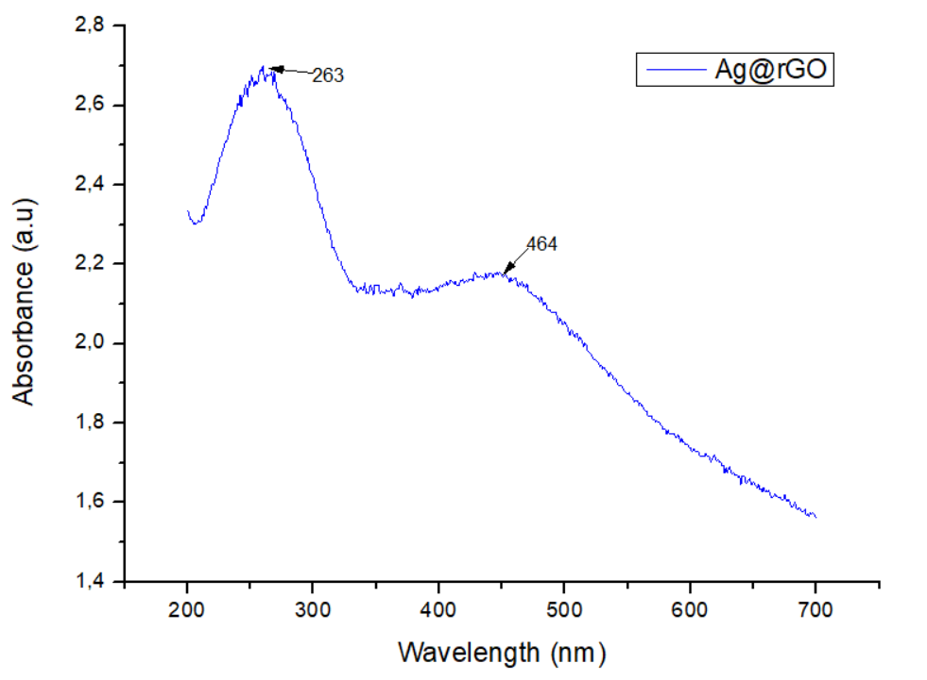*

*Figure 5: UV-Vis wavelength absorbance at wavelength range of 200- 700nm*

* + 1. Photo-thermal conversion efficiency and evaporation rate

The photothermal conversion efficiency and evaporation rate of the Ag@rGO-based interfacial solar steam generation (ISSG) device were significantly influenced by its material characteristics. The integration of silver nanoparticles with reduced graphene oxide (rGO) enhanced light absorption, heat localization, and water transport, resulting in superior solar-to-thermal energy conversion performance.

The morphology and structure of Ag@rGO, as confirmed by SEM analysis, revealed a highly porous network with interconnected micro- and mesopores. This hierarchical porosity facilitated rapid water uptake and vapor escape pathways, crucial for efficient evaporation. The XRD analysis confirmed the presence of crystalline Ag nanoparticles embedded within the rGO matrix, which contributed to localized surface plasmon resonance (LSPR), thereby enhancing photothermal conversion. Furthermore, FTIR spectroscopy validated the reduction of oxygen-containing functional groups in rGO, improving its thermal conductivity and stability under prolonged solar exposure.

The two-layer architecture of the ISSG device played a pivotal role in performance optimization. The Ag@rGO aerogel, acting as the photothermal layer, efficiently captured and converted solar energy, while the polyurethane (PU) sponge beneath functioned as a water transport medium and thermal insulator, reducing heat dissipation. The 3D porous framework further promoted diffuse reflection and effective heat retention, aligning with the principles outlined by Chen et al. (2019).

Under steady-state solar simulation (1 kW/m²), the Ag@rGO/PU system achieved a maximum surface temperature of 42.1°C, indicative of strong photothermal activity. Despite this elevated surface temperature, the bulk water temperature remained at 23°C after four hours, demonstrating the effective heat localization and insulation provided by the PU layer. The calculated evaporation rate (ν) using Equation (1) as indicated by Wei et al. (2022) reached 1.42 kg.m⁻².h⁻¹, making it one of the most efficient systems tested. This high performance was directly linked to the porous architecture and enhanced thermal conductivity of Ag@rGO, which ensured continuous water transport and efficient heat utilization.

$v=\frac{∆m}{S*t}$ (1)

$η=\frac{υ (l_{v}+Q)}{p_{i}}$ (2)

Obtained from Equation 2, the photothermal conversion efficiency of Ag@rGO/PU reached 98.9%, demonstrating its exceptional ability to convert absorbed solar energy into thermal energy with minimal losses. The incorporation of Ag nanoparticles significantly boosted light absorption across a broad spectral range, while the rGO matrix ensured efficient heat distribution. The combination of these properties led to an overall enhancement in evaporation performance. These findings underscore the potential of Ag@rGO as a highly efficient photothermal material for solar-driven water purification. Its superior light absorption, hierarchical porosity, and excellent thermal conductivity position it as a viable candidate for large-scale.

* 1. Conclusions

The study successfully synthesized and characterized Ag@rGO, confirming the integration of silver nanoparticles onto reduced graphene oxide. UV-Vis revealed a plasmon resonance peak at 464 nm, indicating Ag nanoparticles, while SEM and XRD validated their uniform dispersion and crystalline nature. BET showed an increased surface area, enhancing light absorption and thermal efficiency, supported by FTIR results.

Photothermal performance testing demonstrated a high solar-to-thermal conversion efficiency of 98.9% and an evaporation rate of 1.42 kg. m⁻².h⁻¹ under one sun irradiation. The synergy between Ag nanoparticles and rGO improved light absorption, heat localization, and water transport, making Ag@rGO a promising material for solar-driven water purification, effective salt rejection. Future research should focus on optimizing stability and scalability for real-world applications.

* 1. References

Bai H., Zhao T., Cao M. 2020. Interfacial solar evaporation for water production: from structure design to reliable performance. *Mol. Syst. Des. Eng*. 5, 419-432.

Bundschuh J., Kaczmarczyk M., Ghaffour N., Tomaszewska B. 2021. State-of-the-art of renewable energy sources used in water desalination: Present and future prospects. Desalination 508, 115035.

Chen C., Kuang Y., [Hu](https://www.sciencedirect.com/author/12800263400/liangbing-hu) L. 2019. Challenges and Opportunities for Solar Evaporation. *Joule*, [3, 3](https://www.sciencedirect.com/journal/joule/vol/3/issue/3), 683-718.

Farhadipour M., Naghdi B., Roghabadi F.A.,Gorgani A.S. 2024. Highly efficient 3D-screen printed interfacial solar water desalination system. Desalination 584 -117766.

Hidayah N.M.S., Liu W.W., Lai C.W., Noriman N.Z., Khe C.S., Hashim U., Lee H.C. 2017. Comparison on Graphite, Graphene Oxide and Reduced Graphene Oxide: Synthesis and Characterization. AIP Conference Proceedings 1892, 150005.

Habte A.T., Ayele, D. W. 2019. Synthesis and Characterization of Reduced Graphene Oxide (rGO) Started from Graphene Oxide (GO) Using the Tour Method with Different Parameters. *Advances in Materials Science and Engineering*,1- 9.

Jose J.K., Mishra B., Kootery K.P., Cherian C.T., Tripathi B.P., Sarojini S., Balachandran M. 2023. Fabrication of silver nanoparticle decorated graphene oxide membranes for water purification, antifouling and antibacterial applications. Materials Science & Engineering B 297, 116789.

Kim C. B., Lee J., Cho J., Goh M. 2018. Thermal conductivity enhancement of reduced graphene oxide via chemical defect healing for efficient heat dissipation. *Carbon*. 139, 386-392.

Li S., Zhang H., Li S., Wang J., Wang Q., Cheng Z. 2024. Advances in hierarchically porous materials: Fundamentals, preparation and applications. Renewable and Sustainable Energy Reviews 202, 114641.

Liu J., Shuping C., Yanan L., Zhao B. 2022. Progress in preparation, characterization, surface functional modification of graphene oxide: A review. *Jounal of Saudi Chemical Society*, 26, 101560.

Liu S., Li S., Lin M. 2023. Understanding Interfacial Properties for Enhanced Solar Evaporation Devices: From Geometrical to Physical Interfaces. *ACS Energy Lett.*, 8, 1680−1687.

Saeed H.A.M., Kazimoto V.V., Xu W., Yang H. 2024. The Application of Textile Materials in Interfacial Solar Steam Generation for Water Purification and Desalination. *Polymers*, 16, 793

Sun J.,Wu T., Wu H., Li W., Li L., Liu S., Wang J., Malfaita W.J., Zhao S. 2023. Aerogel-based solar-powered water production from atmosphere and ocean: A review. Materials Science & Engineering R 154, 100735.

Sharma B., Rabinal M.K. 2017, Plasmon based metal-graphene nanocomposites for effective solar vaporization. Journal of Alloys and Compounds 690, 57-62.

Thakur A.K., Hazra S.K., Saleque A.M., Bhattarai S., Hwang Y.Y. Ahamed S. 2024. Toward Sustainable Water Solutions: A Review of Nanomaterials for Solar-Driven Water Harvesting. ACS ES&T Water, 4,11, 4741-4757.

Thommes M., Kaneko K., Neimark A.V., Olivier J.P., Rodriguez-Reinoso F., Rouquerol J., Sing K.S.W. 2015. Physisorption of gases, with special reference to the evaluation of surface area and pore size distribution (IUPAC Technical Report). Pure Appl. Chem. 87(9-10), 1051–1069.

Wei Z., Arshad N., Hui C., Irshad M. S., Mushtaq N., Hussain S., Shah M., Naqvi S.Z.H., Rizwan M., Shahzad N., Li H., Lu Y., Wang X. 2022. Interfacial Photothermal Heat Accumulation for Simultaneous Salt Rejection and Freshwater Generation; an Efficient Solar Energy Harvester. Nanomaterials, 12, 18, 3206.

Yang Y., Cao J., Wei N., Meng D., Wang L.,Ren G., Yan R., Zhang N. 2019. Thermal Conductivity of Defective Graphene Oxide: A Molecular Dynamic Study. Molecules, 24, 1103.

Yerragopu P. S., Hiregoudar S., Nidoni U., Ramappa, K. T., Sreenivas A. G., Doddagoudar, S. R. 2020. Chemical Synthesis of Silver Nanoparticles Using Tri-sodium Citrate, Stability Study and Their Characterization. *International Research Journal of Pure & Applied Chemistry* , 21, 3, 37-50

Zhang W.,Fan M., Huang E., Sun J., Zuo Q., Gong L. 2024. Recent developments in natural materials for interfacial solar steam generation: A comprehensive review. Journal of Environmental Chemical Engineering 12, 111787.

Zhou P., Fan W., Sun Y., Zhao Y., Sun F., Xu J. 2024. Highly efficient hydrothermal management, shape-controlled 3D conical aerogels for solar high-salinity seawater desalination and water purification. Chemical Engineering Journal 498, 155529.